**Noise Exposure Toolbox Prototype.** This document provides an overview of how to use a sample version of the Noise Exposure Toolbox discussed in: *Cominelli, S., Leahy M., Devillers, R., Hall, G.,B., 2018. Geovisualization tools to inform the management of vessel noise in support of marine species’ conservation. Journal of Ocean & Coastal Management, under review.*

The toolbox and data described in this document are available in: **[https://github.com/SimoneCominelli/NoiseExposureToolbox.git]**.

To work with the sample as outlined below, you will need ArcGIS Pro 2.1.2 or later installed on a compatible Windows operating system.

## Using the Sample Noise Exposure Toolbox

1. **Importing the Toolbox and Sample Data**

Create a new ArcGIS Pro project (or open an existing one). In the project section of the *Catalog* pane, right click on *Toolboxes* and select *Add Toolbox*. Browse to the folder where the Noise Exposure Toolbox (*NoiseExposureToolbox.pyt*) script is located, select it and press ok.

The toolbox will now be accessible under the *Toolboxes* item in the catalog pane.

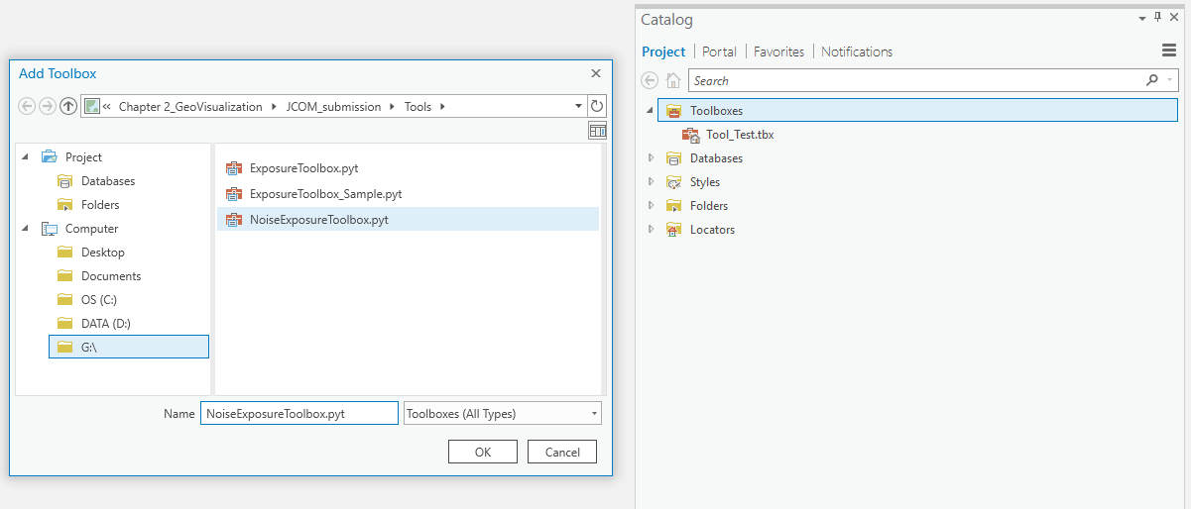

Create a new folder in the C:\ drive and call it *NoiseExposureToolbox*. Copy the Data folder (the one containing the sample data) in the *NoiseExposureToolbox* folder*.*

In the Catalog tab, right click on Folders and select Add Folder Connection. In the dialogue window, browse to the location of the sample-data folder (C:\NoiseExposureToolbox), select it, and press ok. Three geodatabases will be listed under Folders -> NoiseExposureToolbox -> Data:

* Main.gdb
* Noise.gdb
* SpeciesDistribution.gdb

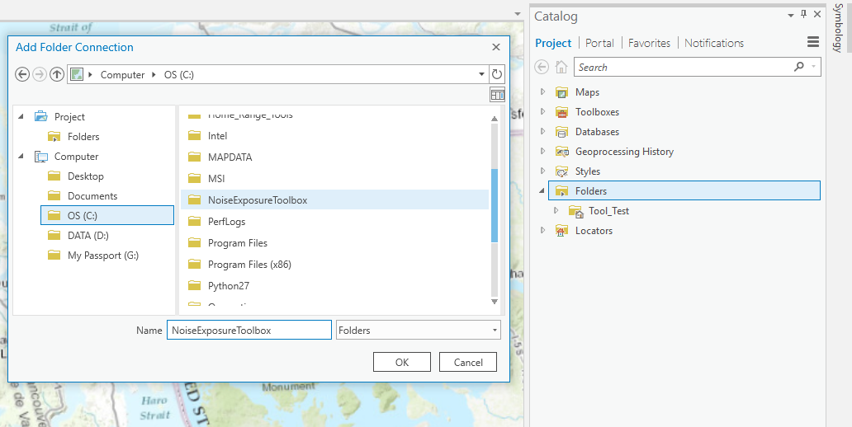

Similarly, the NoiseExposureToolbox contains four distinct geoprocessing tools:

* 1. Generate Noise Exposure Hotspot Map
  2. Compute Exposure CDF
  3. Create Cost Surface
  4. Route Generator

The list of tools can be accessed by double-clicking on *NoiseExposureToolbox.pyt* under the Toolboxes tab.

Before proceeding with the next sections, ensure you have a map added to your project to visualize outputs. You can add a map in ArcGIS Pro by clicking on the *New Map* button found in the *Insert* tab of the main menu ribbon.

1. **Sample Data**

The sample data shared with this version of the toolbox only contains unweighted noise raster for six vessel classes: *Ferries, Containers, Bulkers, Vehicle Carriers, Recreational Vessels, and Tugs*. Model outputs were limited to a simulated receiver located at 10 m of depth and to the summer 2015 season. The list of species has also been limited to one, Killer Whale, and only the Kernel Density Estimations showing the Southern Resident Killer Whale summer core areas are currently available.

A complete list of the sample data is reported below:

**Main.gdb**:

* aoi_polygon_mask ---> Salish Sea AOI - only areas below sea level are included (polygon)
* bc_100m_alb ---> GEBCO bathymety for the Salish Sea AOI (raster)
* Sample_route ---> route used for the application example in the manuscript (line)
* Origin ---> start-point of the sample-route (point)
* Destination ---> end point of the sample-route (point)
* cst_A ---> cost-surface used to generate Scenario A (raster)
* cst_B ---> cost-surface used to generate Scenario B (raster)
* HS1 ---> Boundaries of hotspot 1 (polygon)
* HS4 ---> Boundaries of Hotspot 4 (polygon)

**Noise.gdb**:

* *Ferries* ---> Leq (dB re 1µ Pa) for ferries in the Salish Sea AOI (raster)
* *Tugs* ---> Leq (dB re 1µ Pa) for tugboats in the Salish Sea AOI (raster)
* *Recreational* ---> Leq (dB re 1µ Pa) for recreational vessels in the Salish Sea AOI (raster)
* *VehicleCarriers* ---> Leq (dB re 1µ Pa) for vehicle carriers in the Salish Sea AOI (raster)
* *Containers* ---> Leq (dB re 1µ Pa) for containers in the Salish Sea AOI (raster)
* *Bulkers* ---> Leq (dB re 1µ Pa) for bulkers in the Salish Sea AOI (raster)
* *Ferries_cont* ---> relative percentage contribution to the cumulative noise for Ferries (raster)
* *Tugs_cont* ---> relative percentage contribution to the cumulative noise for Tugs (raster)
* *Recreational_cont* ---> relative percentage contribution to the cumulative noise for Recreational (raster)
* *VehicleCarriers_cont* ---> relative percentage contribution to the cumulative noise for Vehicle Carriers (raster)
* *Containers_cont* ---> relative percentage contribution to the cumulative noise for Containers (raster)
* *Bulkers_cont* ---> relative percentage contribution to the cumulative noise for Bulkers (raster)

**SpeciesDistribution.gdb:**

* *KDE_all* ---> Southern Resident Killer Whale (SRKW) Summer Core Areas Kernel Density Estimation (KDE) (raster)
* *KDE_j* ---> SRKW J-pod Summer Core Areas KDE (raster)
* *KDE_k* ---> SRKW K-pod Summer Core Areas KDE (raster)
* *KDE_l* ---> SRKW L-pod Summer Core Areas KDE (raster)

1. **Generate Noise Exposure Hotspot Map**

This tool produces maps showing the co-occurrence of high noise from shipping and high probability of observing a species within the study area. The tool returns three distinct outputs:

1. Two noise-maps - one expressing the total noise (sum of the noise attributed to each user selected vessel class) as Leq dB re 1 µPa and one containing the corresponding total exponential values. Total noise is computed according to the dB summation formula (Eq. 1 and 2 in Cominelli et al., 2018).
2. A set of percentage contribution rasters, one for each user-selected class, representing the relative contribution of a class to the cumulative noise (Eq. 3 in Cominelli et al., 2018).
3. A Noise Exposure Hotspot Map which combines a species distribution map with the total noise map (i) resulting from the added contribution of all the user-selected classes (Eq. 5 in Cominelli et al., 2018).

The tool requires five inputs: *Select a Cetacean Species (or population)*; *Select Species Distribution Map*; *Select Vessel Classes*; *Select Receiver Depth*; *Select Season*. An optional parameter, Weight Noise by SRKW earing sensitivity, allows selecting outputs of the noise model that have been corrected according to Killer Whale auditory thresholds. However, no model output containing weighted noise values was included in the current version of the toolbox. The output of the tool is stored in a user-defined folder.

**Example A: Noise Exposure Hotspot Map and Percentage Contribution Raster for Ferries, Containers, Bulkers, Vehicle Carriers, Recreational Vessels, and Tugs.**

Southern Resident Killer Whale is the only selectable species in this version of the toolbox. However, four different species distribution map relative to this population can be selected.

In this example, we will use the *Entire Population summer Core Habitat (Kernel Density Estimation)* raster.

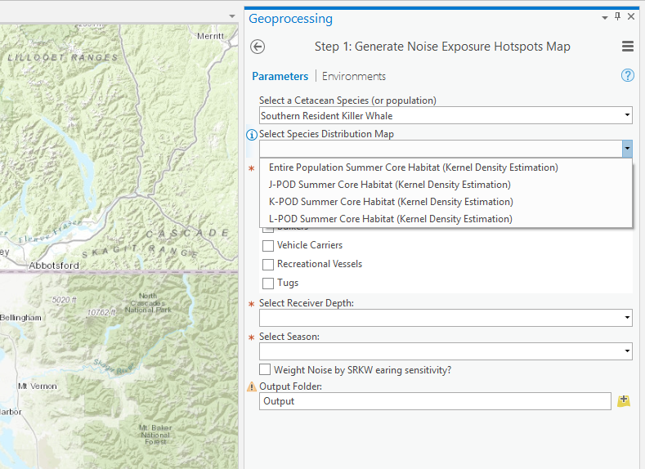

The next step is the selection of the vessel classes that will be considered for the analysis. In this case, we will select all the available classes either by clicking on each one of them or by clicking on the select all button, located on the top right corner of the vessel selection box. Proceed by selecting a *10 m* Receiver Depth and *Summer 2015* as the season.

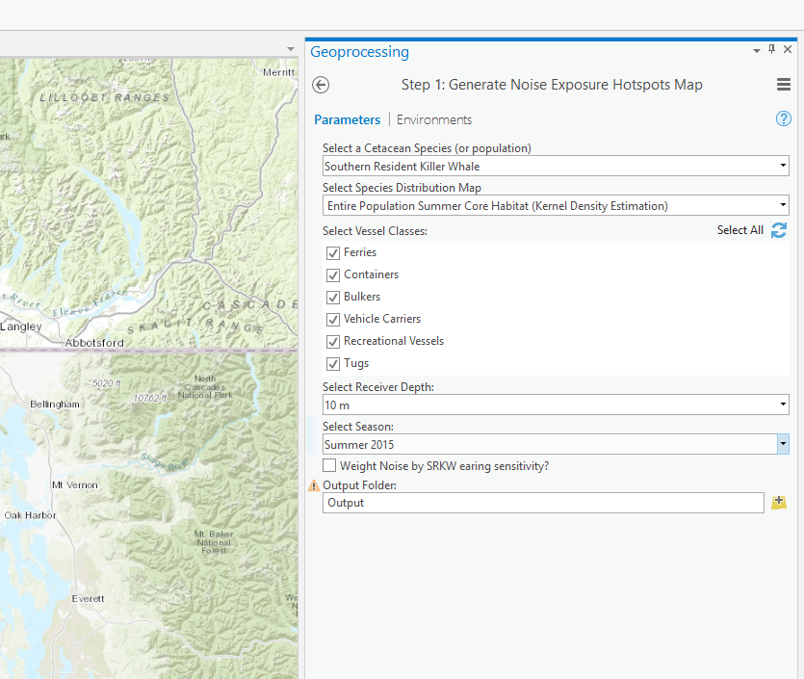

Once all of the input and the output folder are set, press run to execute the tool. Each step of the process is printed to the geoprocessing outputs pane.

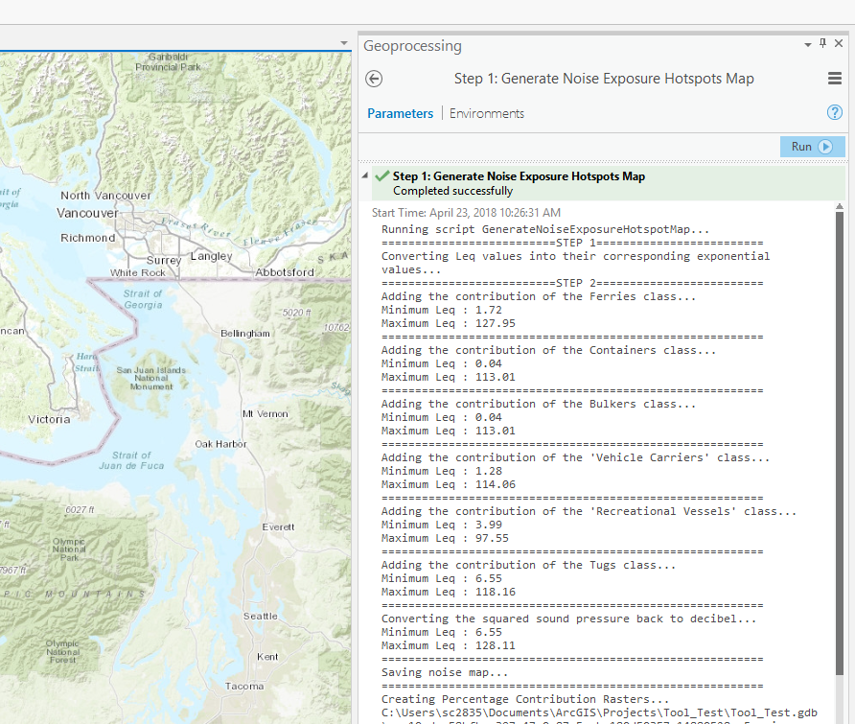

At the end of the process, the output folder will contain a noise exposure map, a noise map in dB and a noise map containing the corresponding exponential values, and a percentage contribution raster for each one of the selected vessel classes.

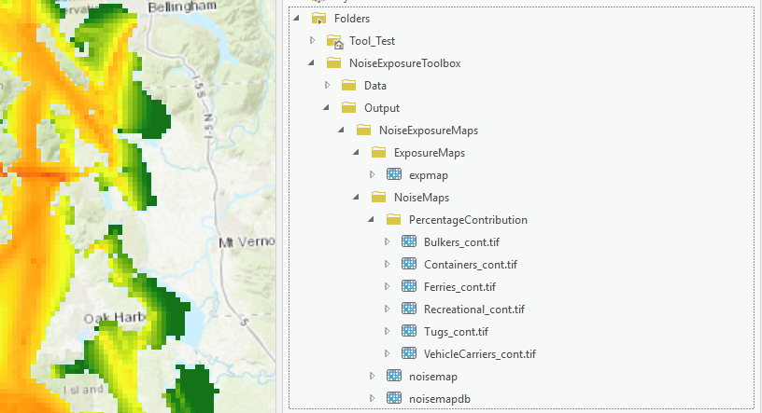

1. **Compute Exposure CDF**

This tool allows generating a cumulative distribution function (c.d.f.) to assess the probabilistic level of exposure to a specific pollutant/entity (e.g. noise, light, vessels) that a marine species would experience over a user-defined AOI. The median value of the distribution can be considered as the median level of exposure. The considered area can either be a polygon defining the limits of a species distribution map or a polygon enclosing a portion of a species distribution map. For example, the 95% and 50% Percentage Volume Contours (PVCs) representing SRKW summer core areas can be used to define the area over which the exposure level will be assessed.

The tool produces three outputs:

i) A raster dataset containing probability values computed from the species distribution map

ii) A scatter plot of p values ~ pollutant values

iii) A CSV file containing the pollutant and probability values

The tool requires 4 inputs: *Species Distribution Map*; *Pollutant Map; Number of points used to compute c.d.f.; Area to analyze.*  The output of the tool is stored in a user-defined folder.

**Example B: CDF for the Ferries class within hotspot HS4.**

In this example, we will create a cumulative distribution function (CDF) to assess SRKW’s exposure to noise from Ferries within the noise exposure hotspot HS4.

Select KDE_All from the SpeciesDistribution.gdb as input for the Species distribution Map parameter. Select Ferries from the Noise.gdb as input for the Pollutant Map parameter. Type 100 for the Number of points used to compute CDF parameter. As area to analyze, select the polygon file contained in Main.gdb. Specify an output folder (ideally in C:\NoiseExposureToolbox) and run the tool.

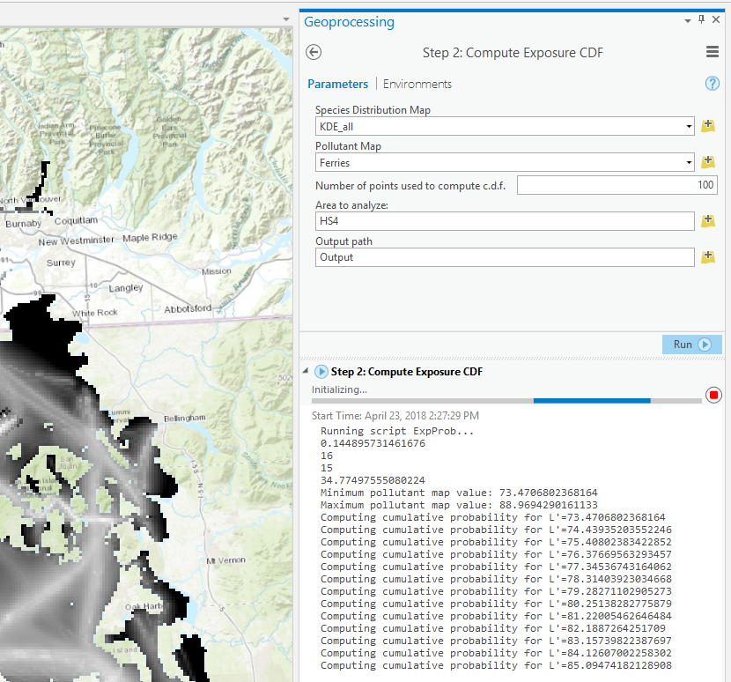

Upon successful execution of the tool, a window showing a plot of the CDF will open and the median level of exposure will be printed to the geoprocessing outputs pane.

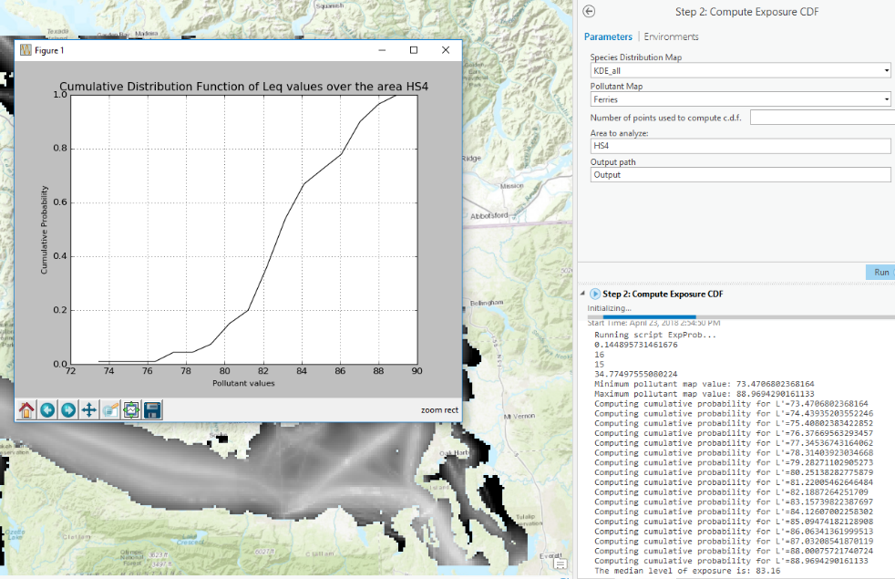

1. **Create Cost Surface**

This tool combines a set of cost-raster datasets into a single cost-surface, ready to be used as input for the Route Generator tool (Least Cost Path Analysis). The tool accepts any number of raster datasets and requires users to assign a weight to each one. Weights range from 0 to 1 and the sum of all weights should be equal to 1. The resulting cost-surface can then re-shaped according to a set of optional parameters which allow users to impose a depth limit (i.e. certain vessel classes cannot navigate in shallow areas) and/or to remove certain portions of the cost-surface (e.g. navigation hazards).

The tool returns a single output, the resulting cost-surface, and has two required parameters: Cost Raster; Weights. Any number of raster dataset can be added to the Cost Raster parameter. For each raster dataset, a weight value needs to be specified in the Weights field.

Under the Options tab, three additional, non-required (optional), parameters can be specified by the user: *Exclude Area Using Existing Polygon?*, *Polygon Feature To Exclude*; *Depth Limit For Safe Navigation*. *Polygon Feature To Exclude* receives a shapefile delineating an area to exclude from the cost surface. This parameter is considered only if the Boolean value *Exclude Area Using Existing Polygon?* is true. The optional parameter *Depth Limit For Safe Navigation* enables users to specify a depth limit for the computation of the cost-surface. Only the cells of the cost-surface with a depth below the specified limit will then be included in the final output.

**Example C: Combining an Exposure Map with Euclidean distance.**

In this example, we will create a Cost-surface suitable to be used in the Route generator tool, starting from the Noise Exposure hotspot Map generated in example A and adding a raster containing Euclidean distances computed from the Origin of a hypothetical route to all the locations within the study area that are deeper than 15 m.

Open the *Output* folder located within the *NoiseExposureToolbox* folder and select the Ferries exposure Hotspot Map (Output/NoiseExposureMaps/ExposureMaps/expmap) as the first raster for the Cost Raster parameter. Set the corresponding weight value to 0.8. Open Main.gdb, located in *NoiseExposureToolbox/Data/* and select the EuD_example raster. This raster contains Euclidean distance values computed from the Origin point feature (located in Main.gdb) and all the cells of the area of interest. Assign the weight value 0.2 to EuD_example and specify a name for the output folder.

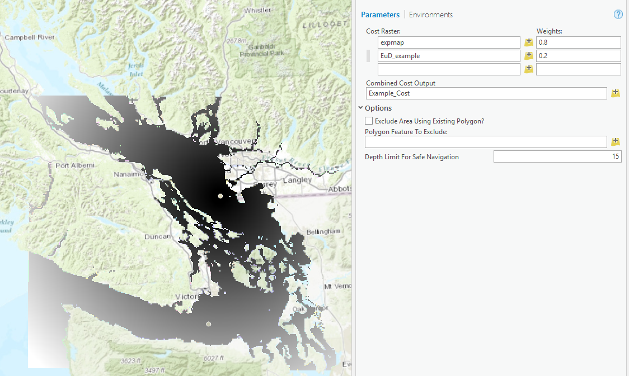

Open the Options tab and type 15 under the Depth limit for safe Navigation parameter. Hit Run to execute the tool. The result is a cost surface combining both noise exposure and Euclidean distance.

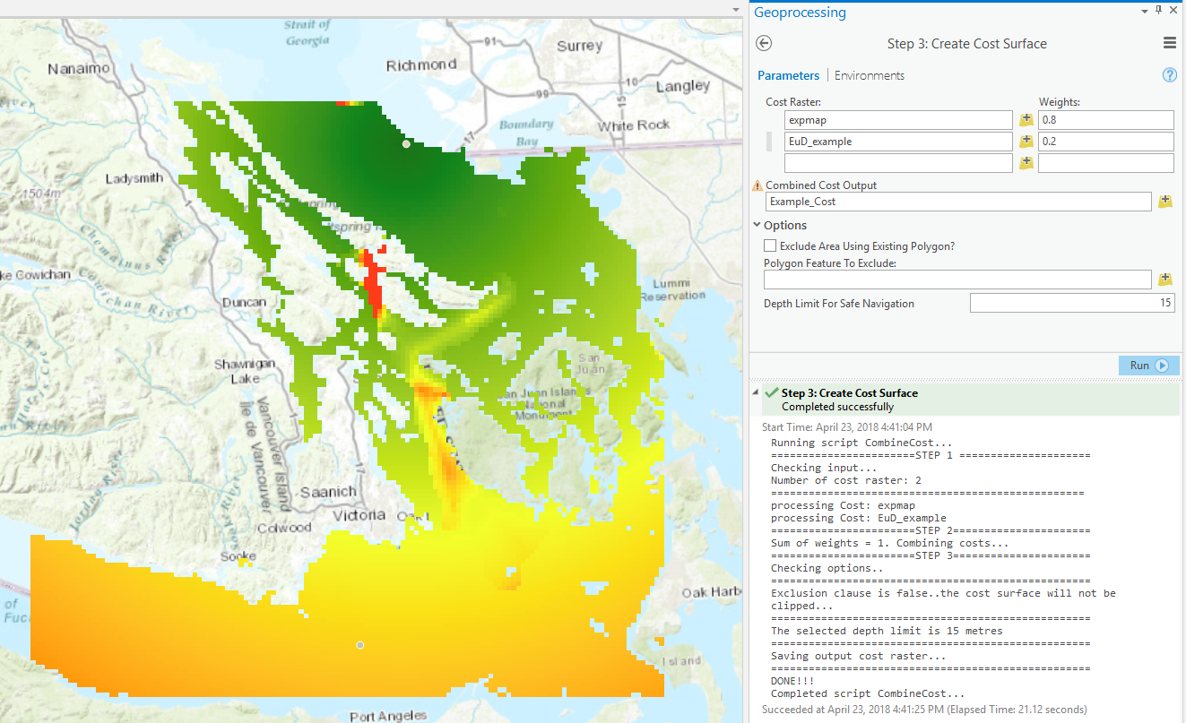

1. **Route Generator**

This tool is based on the Esri Least-cost Path analysis tools. The tool accepts two inputs:

i) A cost-surface (e.g. the final output of the Create Cost Surface tool),

ii) A set of waypoints (min. 2) defining a vessel route

The tool generates two paths: the shortest navigable path between an origin-destination pair of points, without considering any additional distance, and a Least-cost path based on the cost-surface raster. The results are then compared by extracting the accumulated cost along each path and by plotting them on a graph showing traveled distance in km on the x-axis, and accumulated cost on the y-axis.

The tool requires two parameters: Cost; *Sequence of points*. A cost-surface (such as the one generated in Example C) is the required input for the *Cost* parameter. Starting from a minimum of 2, any number of points can be included in the *Sequence of Points* parameter. If > 2 points are specified as input, the points will be processed as Origin-Destination pairs, and one path will be generated for each pair. The output of the tool is then stored in the user-selected output folder.

**Example D: A route to minimize the overlap of vessel traffic with SRKW summer.**

In this example, we will generate the route corresponding to the re-routing scenario (i.e., Scenario A) described in the manuscript. Scenario A was computed using a single cost surface: SRKW summer core area (SpeciesDistribution.gdb/KDE_all).

Browse to SpeciesDistribution.gdb and select KDE_all as input for the Cost parameter. Other two possibilities are the cost-surfaces included in Main.gdb: cst_A and cst_B. Then browse to Main.gdb and select the sample point Origin as the first input to the Sequence of Points Parameter, then select the sample point Destination as the second input. Specify a location for the output and run the tool (the default is C:\NoiseExposureToolbox\Output).

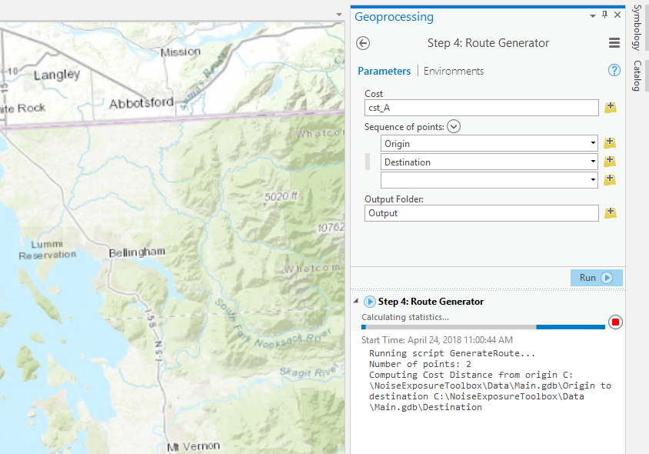

Once the process is completed, a plot showing the difference between the shortest and the optimized (Least-cost) path in terms of accumulated cost is displayed on the screen. Length of both the shortest and the optimized paths, as well as the % difference between the two, are printed to the results in geoprocessing pane.

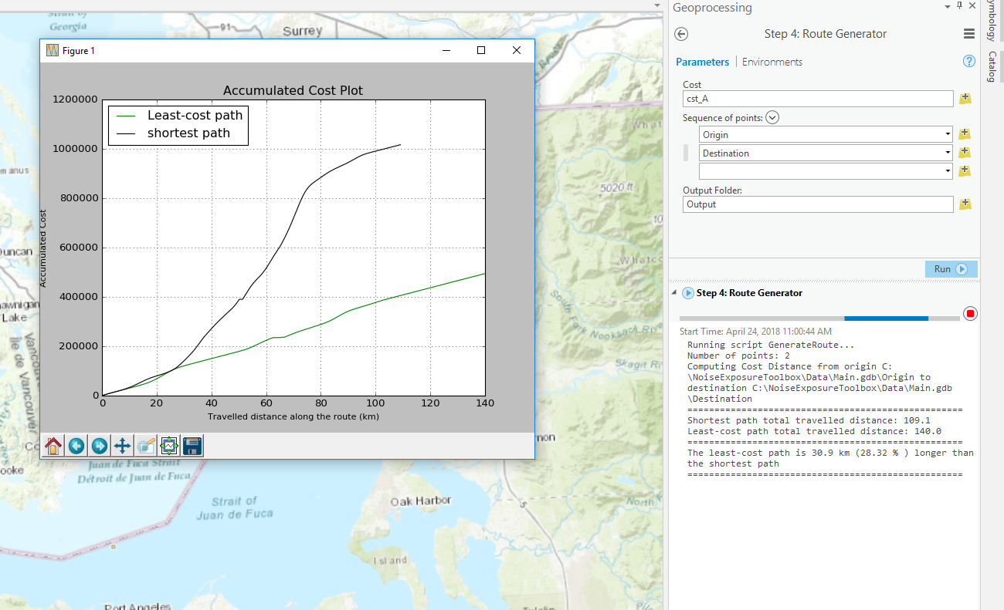

The results can now be added to the map and used for further analysis and/or for the comparison of different re-routing options generated starting from different cost-surfaces. The results are saved in the user-selected output directory, within a folder named after the cost-surface used to generate the paths. For this example, if cstA was selected as cost-surface, the optimized path (black) will be located at:

C:\NoiseExposureToolbox\Output\cst_A\LCP_Output\Paths\Line_Merge.shp

And the shortest path (red) at:

C:\NoiseExposureToolbox\Output\cst_A\LCP_Output\Paths\shortest\Line_Merge.shp

